**Sticky Wicket**

A fun way to fire up your design brain and break through creative blocks - with ideas that stick!

| Type | Creative activity |
| --- | --- |
| Purpose | Creativity and innovation |
| Topics | Teambuilding, communication, creativity, brainstorming, fun, design thinking |
| Audience | Designers |

## **About this activity**

3M scientist Spencer Silver experienced what most of us would call an epic fail. He set out to develop a strong adhesive and instead created a reusable, pressure-sensitive adhesive, which lead to the development in the 1970s of the first Post-It Note.

In Sticky Wicket, this creative accident is taken a step further as participants think about how else the Post-It Note can be used to create a product prototype or work of art. Along the way, participants will define their concept, ideate a finished product, build a prototype, and test its effectiveness. Participants will discover a new hands-on tool to unleash creative thinking and get “unstuck” while working on a design concept or project. This in-person activity works well with designers and teams that use design thinking in their daily responsibilities.

According to a 2021 survey by EMSI Burning Glass, collaboration is the top skill adjacent to design thinking. Participants will put their teamwork skills to the test as they work together in small groups to create a Post-It Note masterpiece!

#### Important details

| Best for groups of | 3-5 participants, up to 75 total participants |
| --- | --- |
| Preparation time | 5 minutes |
| Duration | 45 mins - 1 hour |
| Required materials | * Post-it Notes of various sizes, shapes, and colors * Pens, pencils, markers * Timer or stopwatch * Presentation equipment and screen, if in-person |
| Required location | * Access to screen technology * Indoors * Breakout spaces/tables for small groups |
| Noise level | Medium |

## **How it works**

#### Instructions

Before conducting the activity (5 minutes):

The facilitator will review the instructions and decide how to divide participants for group activity.

Conducting the activity:

Introduction (10 minutes):

The facilitator will introduce the activity by asking participants how they use Post-It Notes and call on a few individuals to answer. The facilitator will inform the participants that they will be working in groups to create a product prototype or work of art using Post-It Notes.

The facilitator will provide ideas of how Post-It Notes can be used to build a prototype product or artwork for display. Ideas include:

* Flying object
* Origami
* Sculpture
* Party decoration
* Pixel art
* Wall decoration
* Garment or accessory
* Hanging mobile
* Mosaic art piece
* Flipbook

The facilitator will break participants into groups of 3-5, depending on the total number of participants, and send them to worktables or breakout rooms.

Group brainstorming (10 minutes):

During this time, small groups will brainstorm their concept and ideate what the group will create with Post-It Notes. The facilitator should remind participants that every team member has to contribute an idea to the finished work and participate in its making.

Once the team has an idea, they should begin selecting Post-It Notes and foraging for other materials that will be used to build their finished work.

Creation (15 minutes):

The small groups work to create their conceptualized piece. The facilitator keeps time and gives 5-minute reminders, a final reminder at 1 minute, and a countdown at 10 seconds to help participants stay on track.

Final Results Sharing and Wrap-Up (10 - 25 minutes, depending on number of groups):

The facilitator gathers all participants back to the main meeting room or space and asks each team to present their work to all participants. Each team is encouraged to share how they developed their idea, their creative process, and what each group member contributed to the finished work.

Once every group has shared their finished work, the facilitator asks all participants how this exercise could be useful in their design process.

The facilitator encourages participants to document their creations with photos and share them with the team.

#### Rules

Every team member has to contribute an idea to the finished work and participate in its making.

No phones or computers can be used to brainstorm ideas or look up instructions.

Post-It Notes must be the primary material in each work, but participants can use other materials that are readily available when creating their work.

#### Example

An example of a Post-It Note work is a pixel art installation, created by arranging square Post-It Notes of different colors on a blank wall canvas.

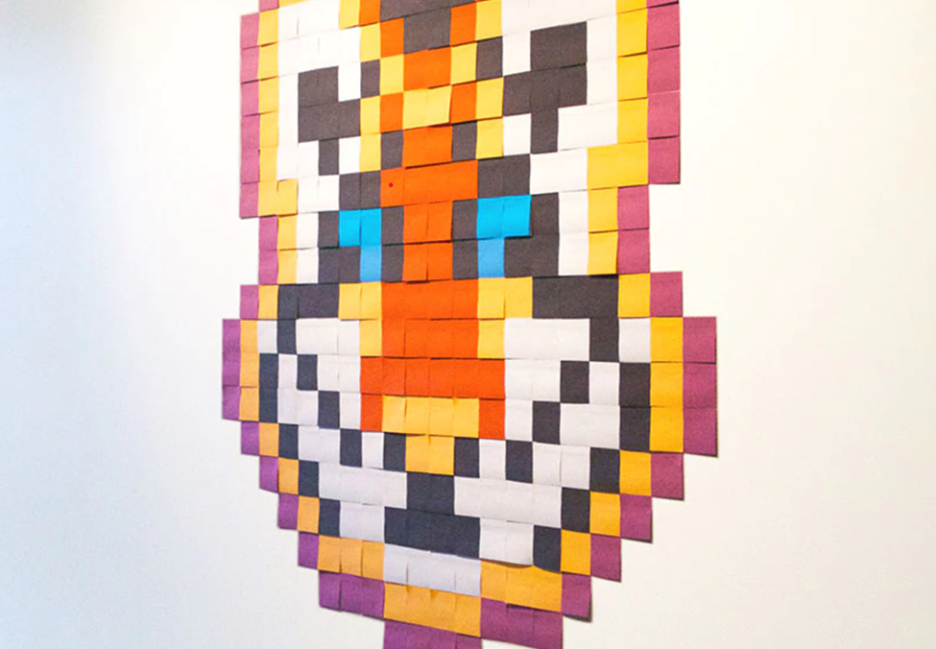

## **Materials**

#### For facilitator

Printed or screen share example of a pixel art project created with Post-It Notes

Post-it Notes of various sizes, shapes, and colors

Pens, pencils, and markers

Timer or stopwatch

Presentation equipment and screen, if projecting example image